EXERCISE-18

18.Design TM using simulator to accept the input string ww

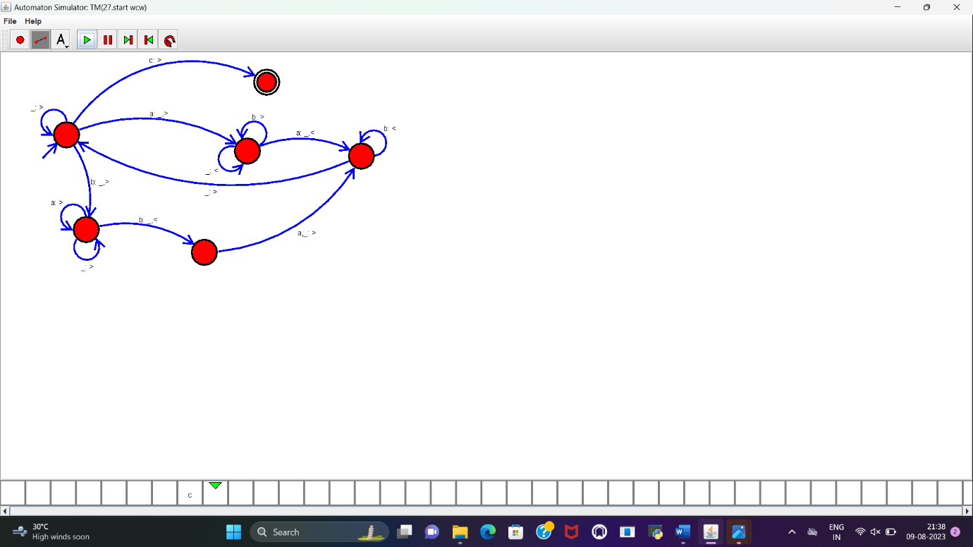

RESULT:

TM to accept the input string WW is designed and implemented successfully.